IICT
Aleena Zahra 23i-2514, Ayman Irshad 23f-0724, Ishmal Faheem 23i-5032, Abdul Rafay 23i-2563

Final Project - ZooUtopia
Report on Website

Aleena Zahra

Header
The header for the website. It is the same on each page. Hovering on a name turns its color to green. Clicking ‘What we are upto’ opens a scroll down option that shows further webpages.


Header on a smaller screen
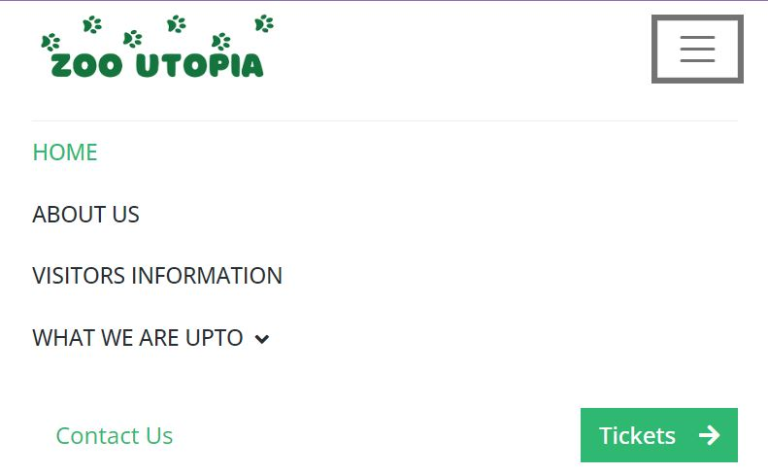
The header on smaller screens only shows the zoo utopia icon and menu icon. When the menu icon is pressed, the menu bar opens and displays the names of the rest of the pages on the site.

Homepage

Home Carousel
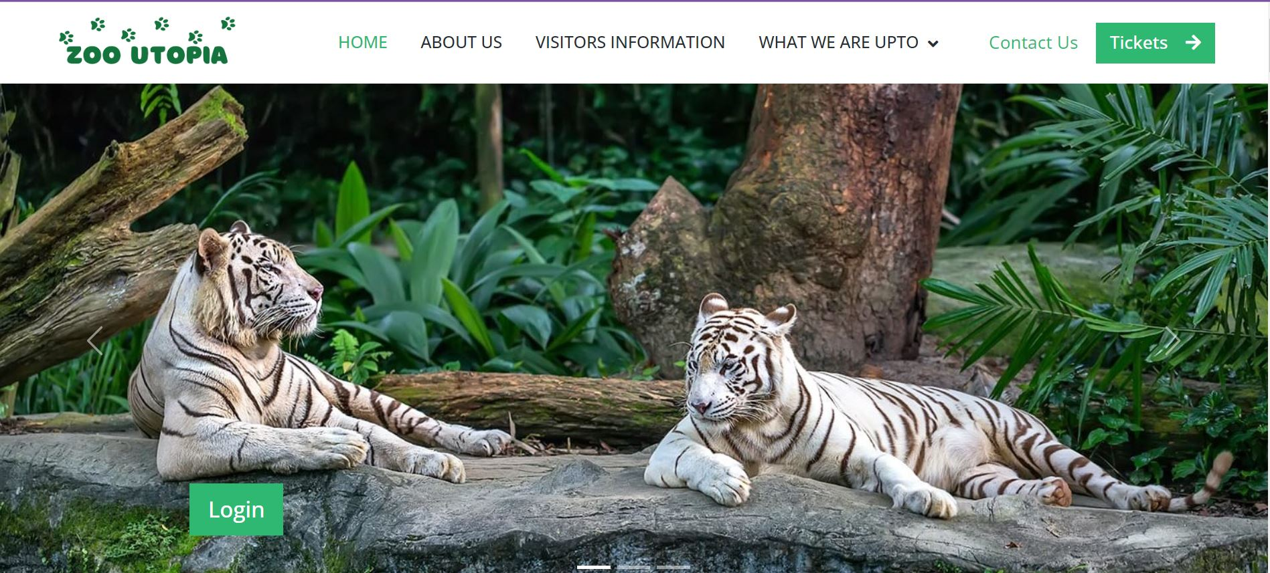

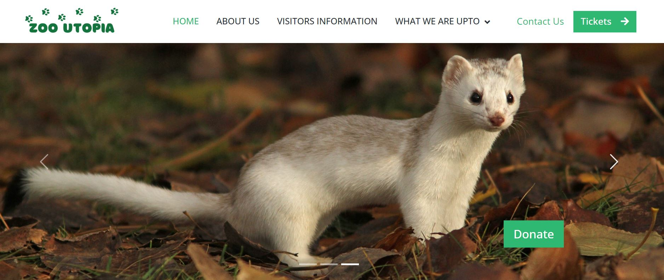
The header of the homepage is a carousel that moves every few seconds. Each image has a different button. The first image has a login button, the second has a button that takes the user to zoo Education page, the third page has a donate button.

Animal Gallery
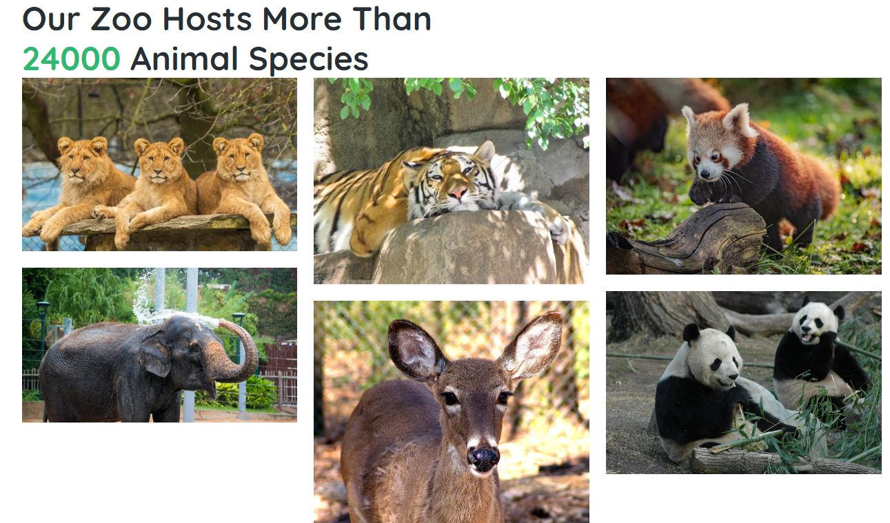
A gallery of animals that displays some of the popular animals in the zoo. This helps the zoo to showcase some of their animals, to attract people towards their zoo, take part in educational programs to learn about these animals or donate to support them.
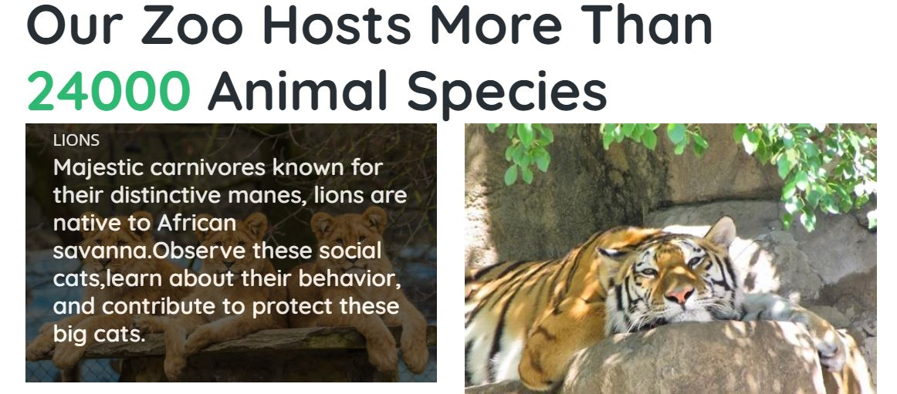
When the user hovers over the image of an animal, more information for that animal is displayed.

Login Page
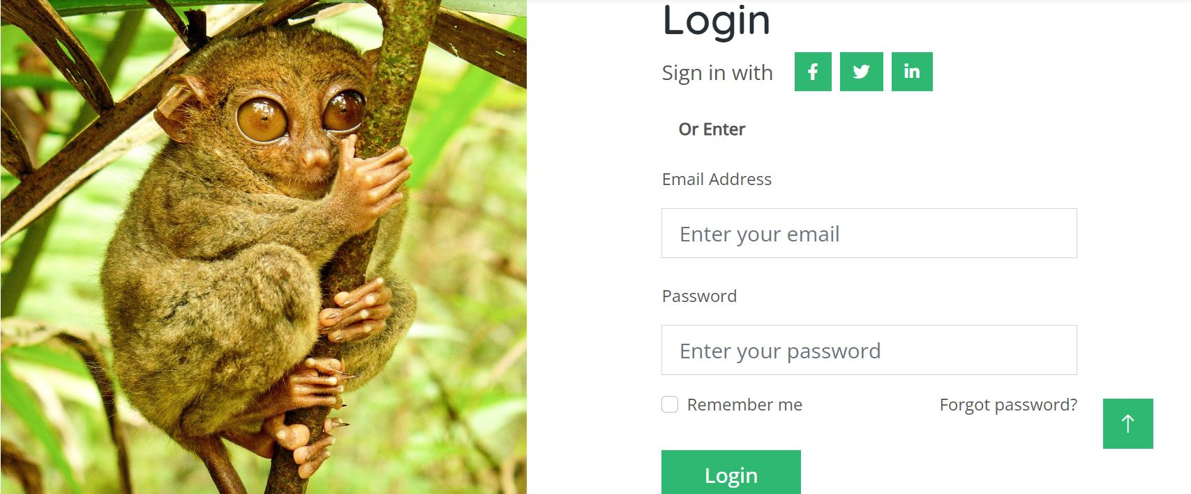
Users can login if they enter a valid password and email. Checkbox for ‘remember me’ is given. There is a picture alongside the login form. Icons for social media platforms are given if users want to login with their social media credentials.

Donation Page
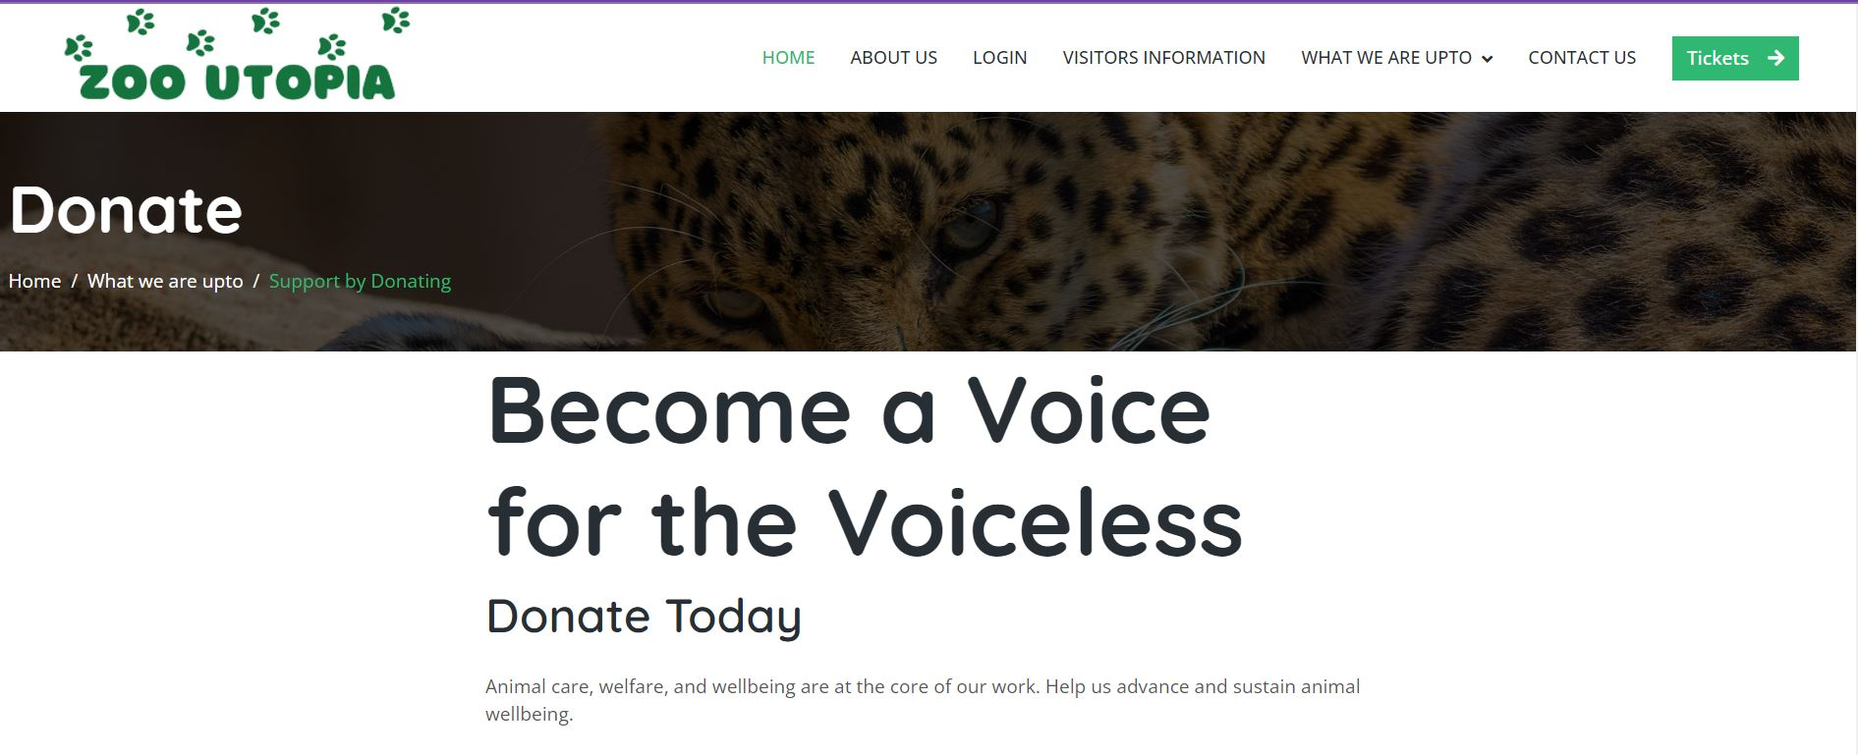
Donation page Header and Headings to prompt and convince the user to donate to the zoo organization.
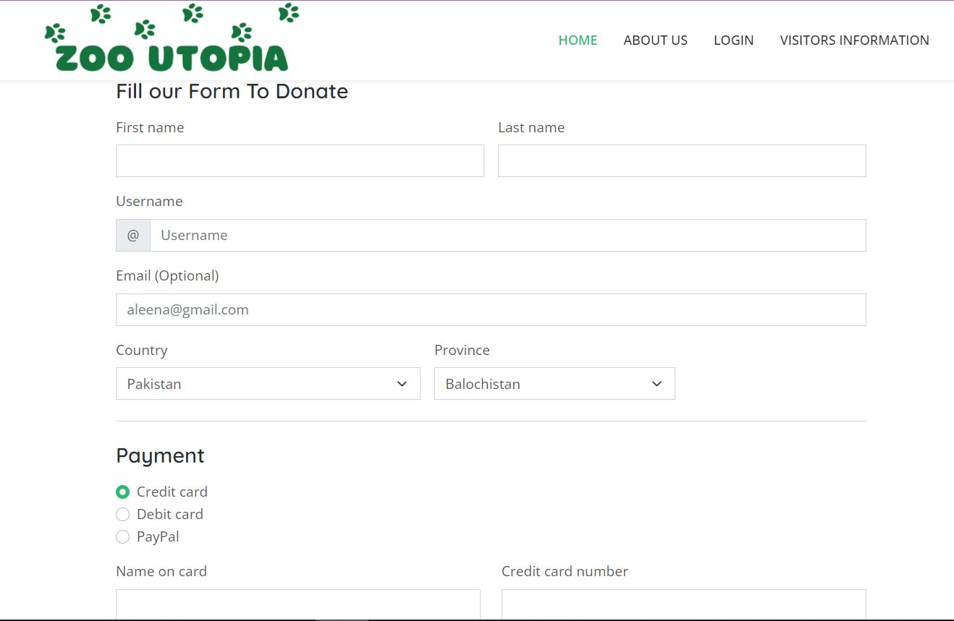The donation form asks the user to input their name, username (if they have an account and donate repeatedly), their country and province of residency. 
The Payment options are checkboxes, only one can be selected at a time. The country and province options are scroll down options.

If form values are left empty: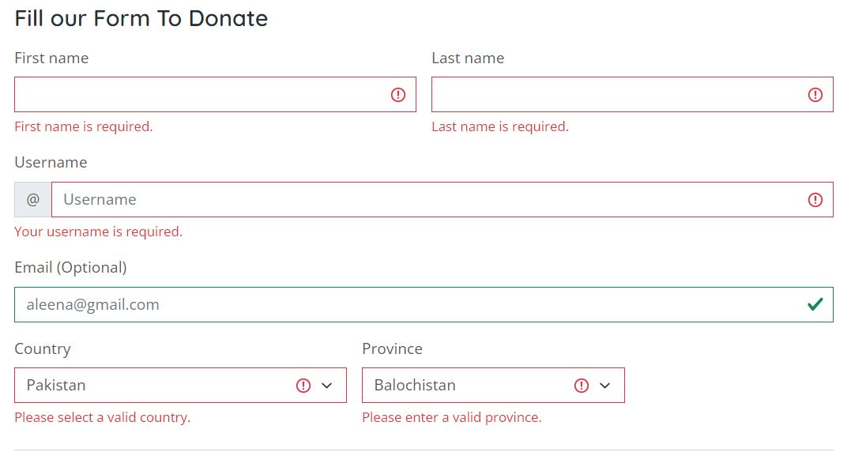
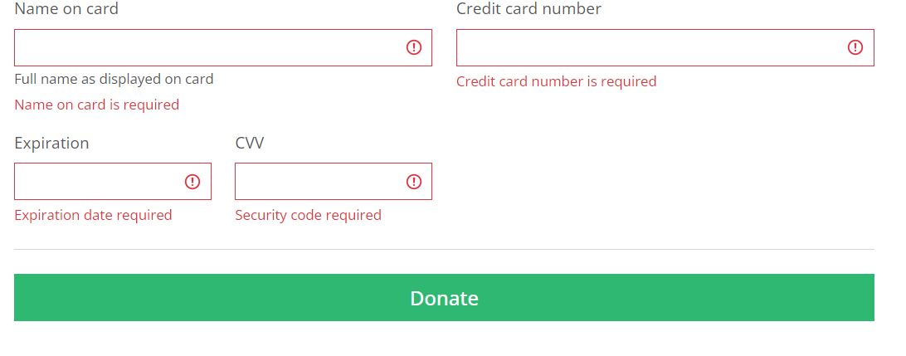
When the user does not enter the appropriate values in the form, an error message in red shows up. As emails are optional there is no error below that.
Events and Exhibitions Page
This shows the multiple events currently happening in our zoo along with information about the date and time of these events. The pictures further elaborate on these events.
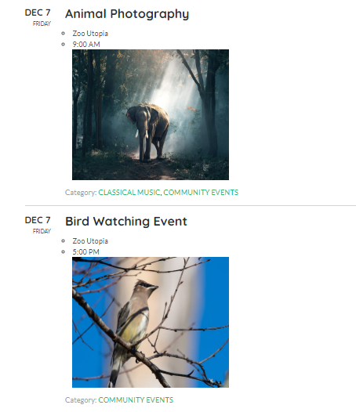
Tickets
The online tickets page sells the tickets to these events. The event name is written on these tickets and also details about the whereabouts of the event and at what time the event would be staged.
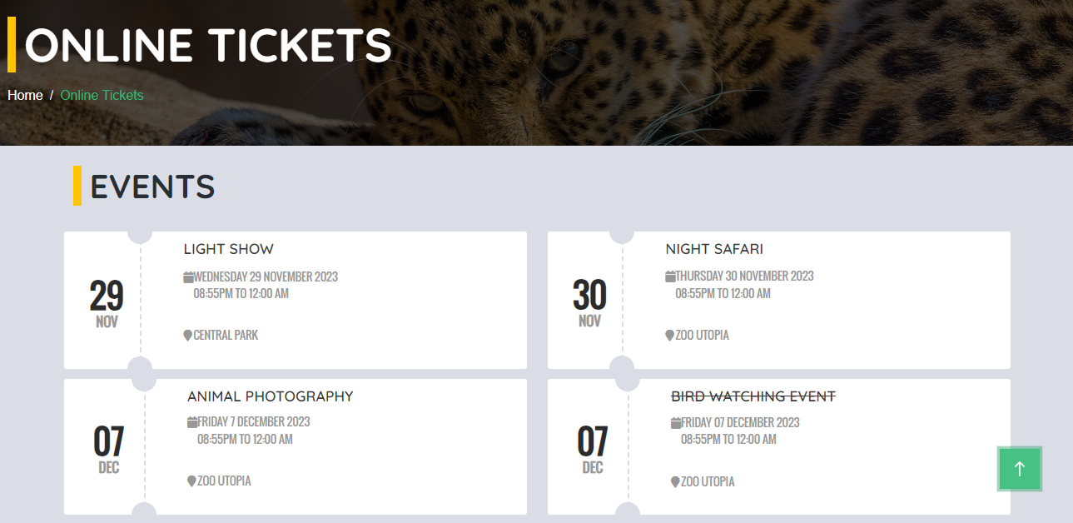

Footer

Footer contains three links. ‘Home’ takes the user to the homepage. ‘Contact us’ takes the user to zoo Contact page. ‘About us’ takes the user to About Us page.
Additionally, the footer contains credits to the authors, and their name links to a thankyou image. There are also three icons for facebook, twitter and linkedIn respectively.
Upon clicking the arrow, the user is taken to the top of the page.
These features are on every page

